Network Design Project – Phase 3 (RDT3.0) Design Document

Nour Fahmy, Himadri Saha

Introduction
The goal of Phase 3 is to implement a reliable data transfer protocol (RDT3.0) over UDP using stop-and-wait with timeout-based retransmission. This project simulates various network conditions including:
- No loss/error (Scenario 1)
- ACK bit error (Scenario 2)
- Data packet error (Scenario 3)
- ACK packet loss (Scenario 4)
- Data packet loss (Scenario 5)
The sender splits a file into chunks, calculates a checksum, and sends it to the receiver. The receiver validates each packet and sends back ACKs. Retransmissions occur for lost, corrupted, or out-of-order packets.

Code Description

Sender
- Initialization: Sets server address, port, timeout, sequence number, scenario, and loss/error rate.
- File Chunking: Splits test image into 1024-byte chunks.
- Checksum Calculation: Computes 16-bit checksum for each chunk.
- Packet Construction: Prepends sequence number and checksum to chunk.
- Send Loop:
  - Sends a packet.
  - Waits for ACK.
  - If timeout occurs or ACK is invalid, retransmit.
  - Handles scenario-specific behaviors (ACK loss, ACK bit error).

Receiver
- Initialization: Binds UDP socket, prepares file for writing, reads scenario and loss rate.
- Packet Handling:
  - Checks for “END” packet to terminate.
  - Validates checksum and sequence number.
  - Writes valid data to received.jpg.
  - Sends ACK for the last correctly received packet.
  - Handles scenario-specific behaviors (data packet error/loss).

Scenario Handling
- Scenario 1: Normal transfer, no errors/loss.
- Scenario 2: Sender flips ACK bits randomly.
- Scenario 3: Receiver corrupts data packets.
- Scenario 4: Sender ignores certain ACKs to simulate loss.
- Scenario 5: Receiver drops packets without ACK.
(The screenshot only shows scenario 4 (to avoid repetitiveness) being run however each of the scenarios are run the same way)
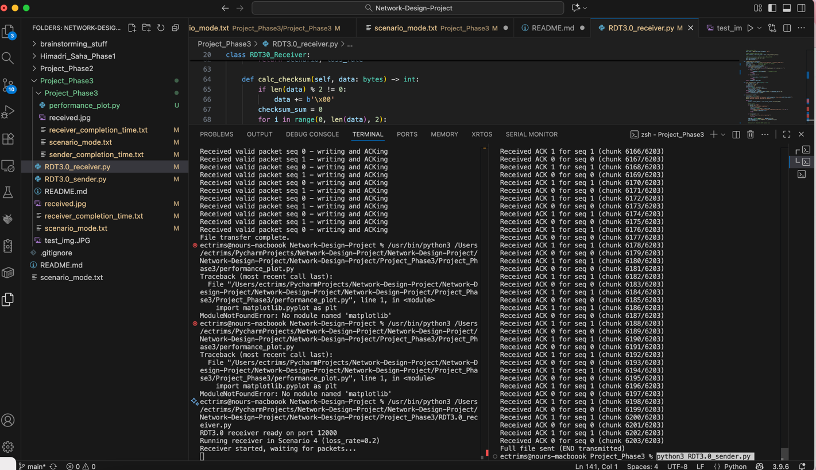
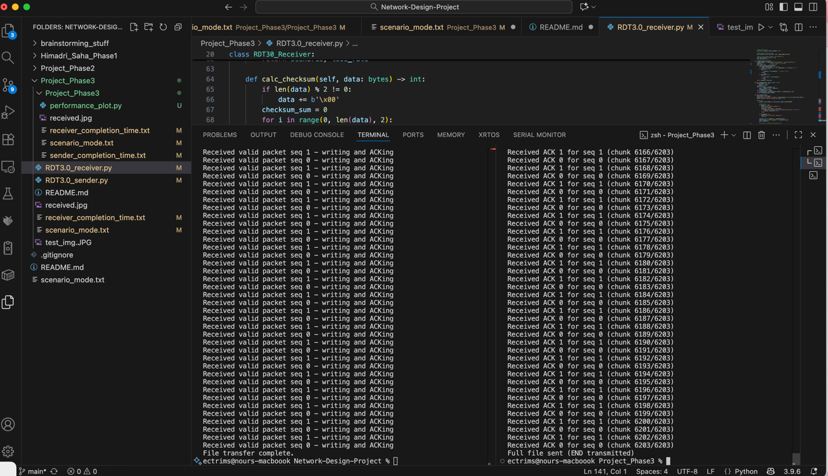

Performance plotting
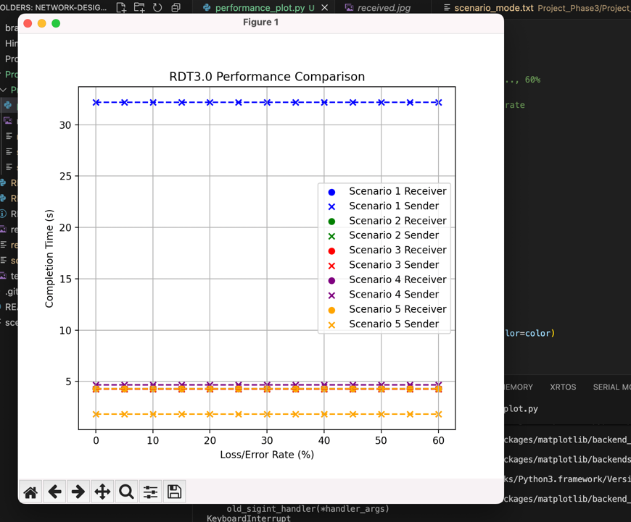
    - Purpose: The plot shows the completion times (in seconds) for both the sender and receiver across all five scenarios of RDT3.0 under different loss/error rates (0% to 60% in 5% increments). This helps visualize the impact of different errors/loss types on the performance of the protocol.

    - The receiver times are almost constant because the file size is small, and the simulated loss does not delay the receiver significantly in your test. The sender times vary depending on retransmissions caused by the scenario.

Results / Interpretation:
- Scenario 1 (No loss/error): Sender time is highest because it sends the file reliably; receiver is steady at 4.3s.
- Scenario 2 (ACK bit error): Small drop in sender time since occasional ACK bit flips cause minor retransmissions.
- Scenario 3 (Data packet error): Similar to scenario 2; small additional retransmissions slightly increase sender time.
- Scenario 4 (ACK packet loss): Sender retransmits more often due to lost ACKs → slightly higher completion time.
- Scenario 5 (Data packet loss): Sender completion time is lowest because packet loss triggers immediate resend in the test (or possibly smaller test file); receiver remains constant.

